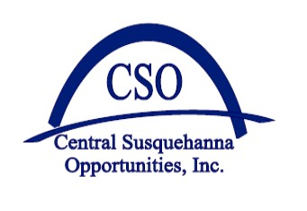
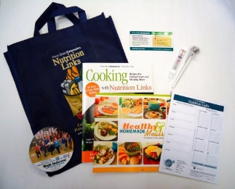
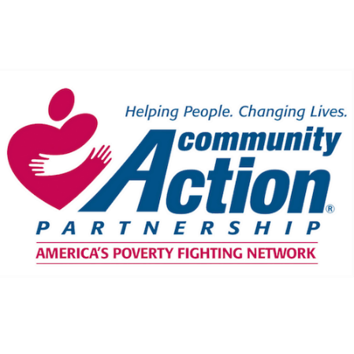
CSO is offering Free Online NUTRITION LINKS Programs to Learn Money Saving Tips and Recipes!

This is a Free Workshop Series for parents and grandparents with children (receiving WIC/SNAP/Food Pantry Giveaways/Free and Reduced School Meals) to discuss ways to save at the store while improving your family’s budget and health. Different weekly topics. Drop-in for one or complete the series and receive a bag of kitchen tools and a Penn State Extension Certificate. Bring a friend.

* BY ATTENDING THE WHOLE ONLINE SERIES (6 meetings and two surveys) YOU WILL RECEIVE A REUSABLE SHOPPING BAG WITH A VEGETABLE PEELER, MAGNETIC SHOPPING LIST, MEASURING CUPS, COOKBOOK, CUTTING BOARD, FOOD THERMOMETER, REFRIGERATOR THERMOMETER, GRADUATION CERTIFICATE, AND MORE.*

Where: Zoom: https://psu.zoom.us/j/5705564742 (on ZOOM app enter Meeting ID 5705564742), OR join by phone, call 570-556-4742, 15 minutes before class time to get the special meeting dial-in number.
When: Thursdays, 9:00-10:00 AM or 6:00-7:00 PM
Household Members | Maximum Monthly  Income
2 | $2,658
3 | $3,349
4 | $4,039
5 | $4,730

Questions: Text or call: Cyndi Clayton 570-556-4742, email cac53@psu.edu

Participants Will:
- Learn how to cook low-cost healthy meals.
- Find tips to keep your kitchen and food safe.
- Become skilled meal planners and shoppers.
- Learn how to read food labels to buy the best foods.
*The average family saves about $100 a month on groceries after attending this program series.
This material was funded, in part, by the Expanded Food and Nutrition Education Program (EFNEP), which is supported by the National Institute of Food and Agriculture, U.S. Department of Agriculture, and funded, in part, by USDA’s Supplemental Nutrition Assistance Program (SNAP) through the PA Department of Human Services (DHS). Any opinions, findings, conclusions, or recommendations expressed in this publication are those of the author(s) and do not necessarily reflect the view of the U.S. Department of Agriculture. This institution is an equal opportunity provider. Penn State College of Agricultural Sciences research and extension programs are funded in part by Pennsylvania counties, the Commonwealth of Pennsylvania, and the U.S. Department of Agriculture.
Pennsylvania State University encourages qualified persons with disabilities to participate in its programs and activities. If you anticipate needing any type of accommodation or have questions about the physical access provided, please contact Cyndi Clayton at 570-556-4742 in advance of your participation or visit.
This publication is available in alternative media on request.
Penn State is an equal opportunity, affirmative action employer, and is committed to providing employment opportunities to all qualified applicants without regard to race, color, religion, age, sex, sexual orientation, gender identity, national origin, disability, or protected veteran status

